**Software Testing Assignment**

**Module–1(Fundamental)**

* What is SDLC

SDLC means a software development life cycle that includes the planning point to the maintenance.

Planning is required in SDLC as it gathers all the requirement of the client and their need to develop the software and plan it according to that.

every software needs preparation before the development as to when-, what, and how to do.

The evaluation is also a part of SDLC were evaluate the developed software and reviews it.

Launching the software product and doing the software-related work and maintaining the software product.

This is the whole SDLC which has different phases and the whole life cycle of software development.

* What is software testing?

Software testing is a process of finding defects, correcting defects, and assuring and maintaining the quality of software.

* What is agile methodology?

Agile methodology is a combination of Iteration and Incremental models. It gives flexibility for combining both models’ pros to this methodology where client satisfaction is prioritized by doing rapid delivery of software products.

* What is SRS

SRS (software requirement specification) is the documentation for any software, made as per the client’s requirement and need with all the details and as per the rules and regulatory guidelines of IEEE 830-1998.

* What is oops

Oops is object-oriented programming. Where overcoming the typical procedural programming method. Here identifying the object and assigning the responsibility.

* Write Basic Concepts of oops

The basic concepts of oops are

Class

Object

Encapsulation

Abstraction

Polymorphism

inheritance

* What is an object

Everything around us is an object.

An object is a data member and its methods/functions.

* What is class

Class is a blueprint of the project. Class is space for objects, without it class does not occupy any space.

* What is encapsulation

Encapsulation means wrapping up any properties or methods of an object. We can encapsulate (can hide) any of the object properties/functions written in programming if we don’t want to show them at a time.

* What is an inheritance

Inheritance is having similarities of function or method in two different classes of objects. So we can inherit the same code for another programming.

It says that we can reuse the code in this oops concept. Same as having a similarity between a parent and a child.

* What is polymorphism

Polymorphism says having many forms.

There are two types

1. Overloading: Overloading is a static form.

Where a problem arises: same class having same name method.

Solution: give an additional parameter or name to the same method.

1. Overriding: Overriding is a dynamic form.

Where a problem arises: Different classes have the same name method.

Solution: while writing the class, write inherit. parent class (name)

* Draw Usecase on Online book shopping

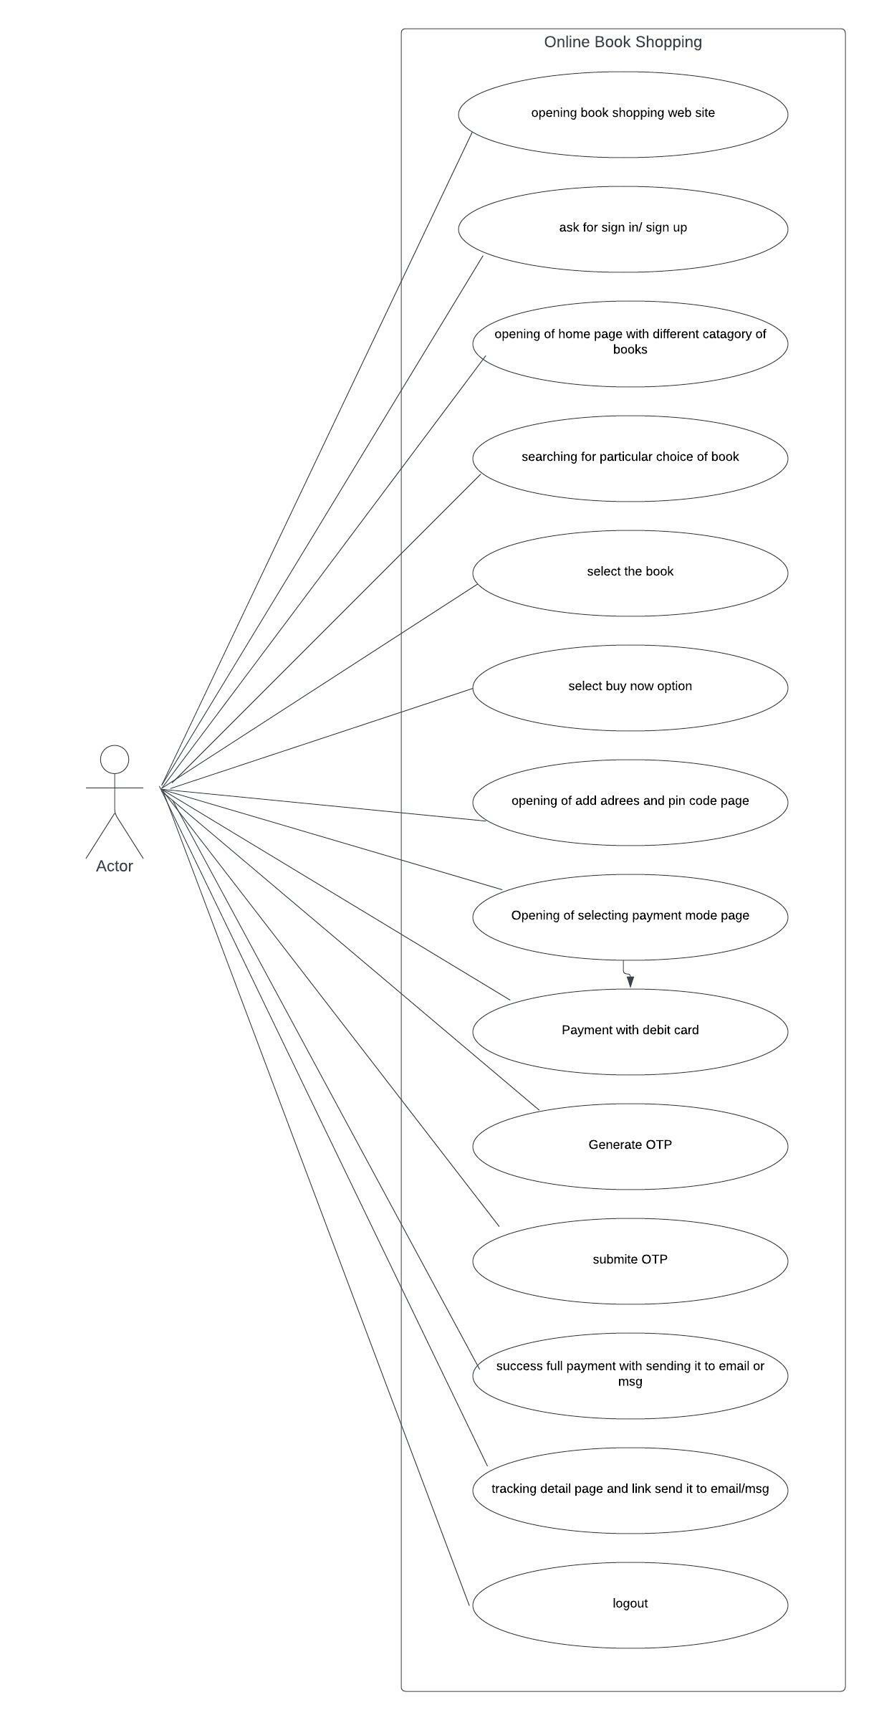

* Draw Usecase on the online bill payment system (Paytm)

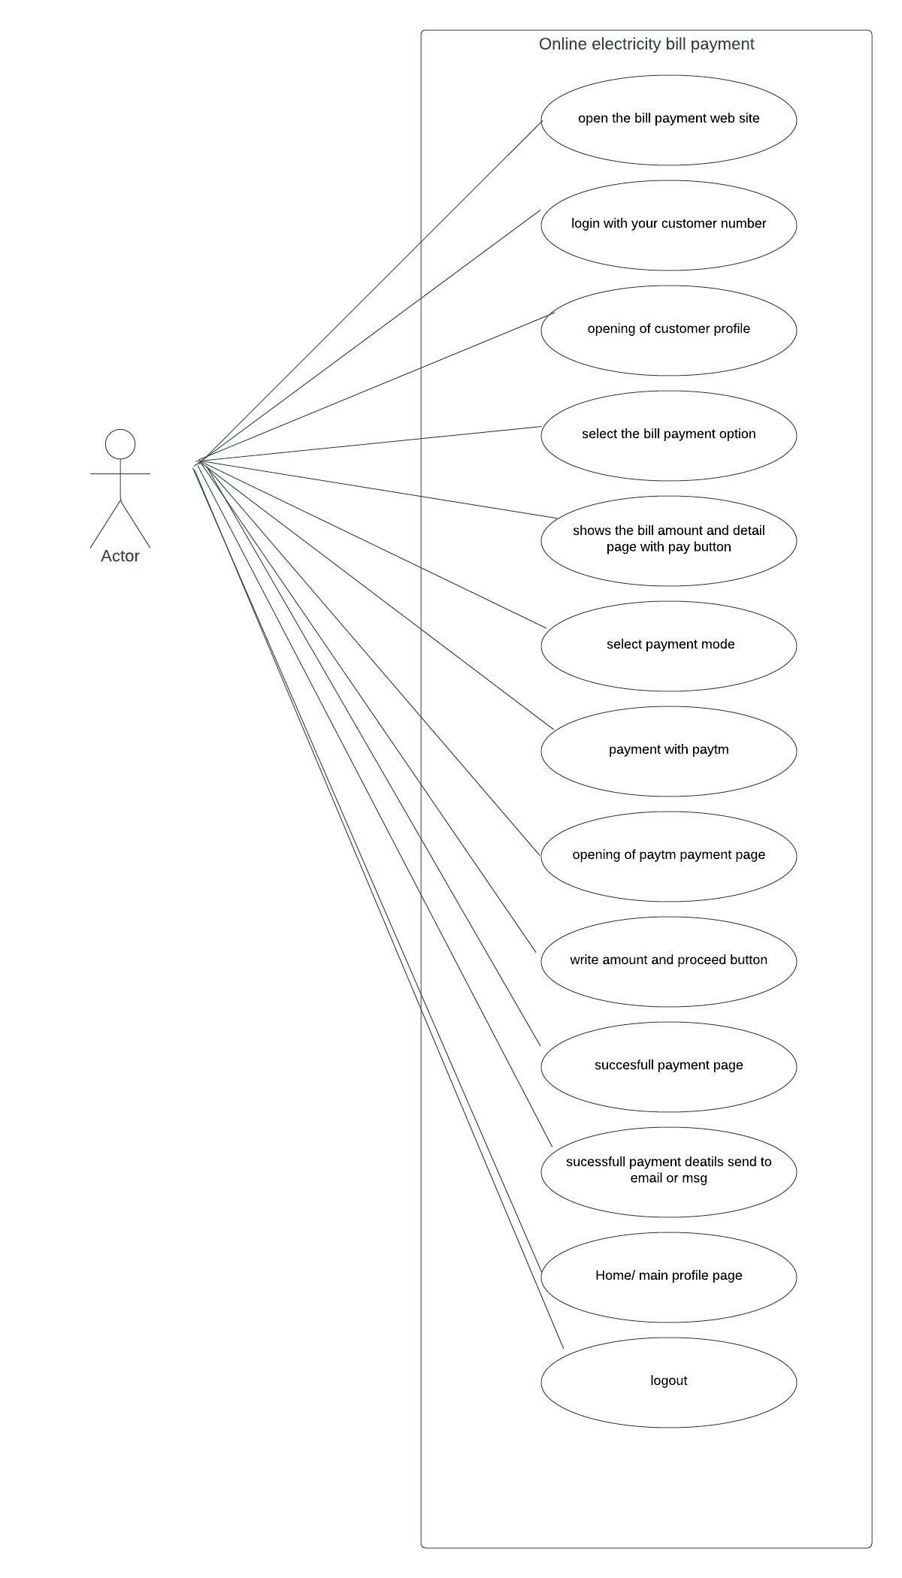

* Write SDLC phases with a basic introduction

SDLC phases are

Requirement collection/gathering: collecting all the requirements for the software development according to the client’s needs.

Analysis: analyzing all the requirements and documentation to plan how and what to do.

Designing: designing the different modules as per the client’s criteria and setting the blueprint for a developer.

Coding: coding the software is one of the important phases where the developer writes the code according to the design.

Testing: testing of software should be done to find out overall flow is ok, if any defect is there then resolve it and assuring the quality.

Maintenance: maintenance is a phase when software is fully developed and launched after that any changes or regular checks and new features are considered as maintenance.

* Explain the Phases of the waterfall model

The waterfall model has typic phases. It is a model which has restrictions on the non-changing requirement and at a time only steps. It’s necessary to test before going on next phase.

Requirement collection: collecting all the requirements for the software as per documentation and client’s need.

Analysis: analyzing the details for the preparation of the designing phase that which sources and other things are needed.

Designing: Designing is a blueprint of software that how its looks and how the moduls will look.

Implementation: coding is an implementation phase where coding is done.

Testing: before going to this phase coding should be done properly and testing should be done for finding the proper flow of product and quality, if found any major defect then we can not go further.

Maintenance: this phase comes at last after the lunch of the product as after that any new feature added or to maintain regular flow all comes as maintenance.

* Write phases of the spiral model

The spiral model work for a risky project and customer satisfaction is the most preferable thing.

The spiral model’s phases are:

Planning: planning is done as per all the requirements and needs.

Risk analysis: this is done for the project in detail, that’s why this model is very preferable for high risk and security.

Engineering: where designing of software and programming is done. It says kind of engineering thing.

Customer evaluation: here in spiral methodology testing is done by customer evaluation. Customer satisfaction is the most important and after the cycle if any requirements and changes are added then again cycle is repeated. This is a phase of the spiral.

* Write agile manifesto principles

Agile manifesto principles are:

* Satisfaction of customers due to early and continuous delivery of work.
* As a facility of two methodologies, it breaks the work into smaller parts and it becomes easy to work and finish early.
* For getting the best work self-organized team is a must.
* Changing requirements are welcomed in even the late stages of the project also.
* Progress is accounted as per the completed work till that time.
* Efforts are very valuable in this model.
* Explain the working methodology of the agile model and also write the pros and cons.

Agile methodology is a combination of Iterative and Incremental models. As Iterative model gives review benefits and the incremental model breaks the work into smaller parts. As both combine every part of the work is tested and reviewed and any change in requirement is welcomed again work on that.

Pros of the agile model:

* Suitable for big & complex projects
* Flexibility and adaptability to get new or change requirements.
* As work is distributed, less resources are required.
* Early delivery of partial submission work
* The documentation part is less

Cons of the agile model:

* Very complex dependency handling is not suitable
* Heavily depends on customer interaction
* Transferring technologies to new members may be quite challenging due to less documentation.
* Draw a use case for Online shopping products using COD.

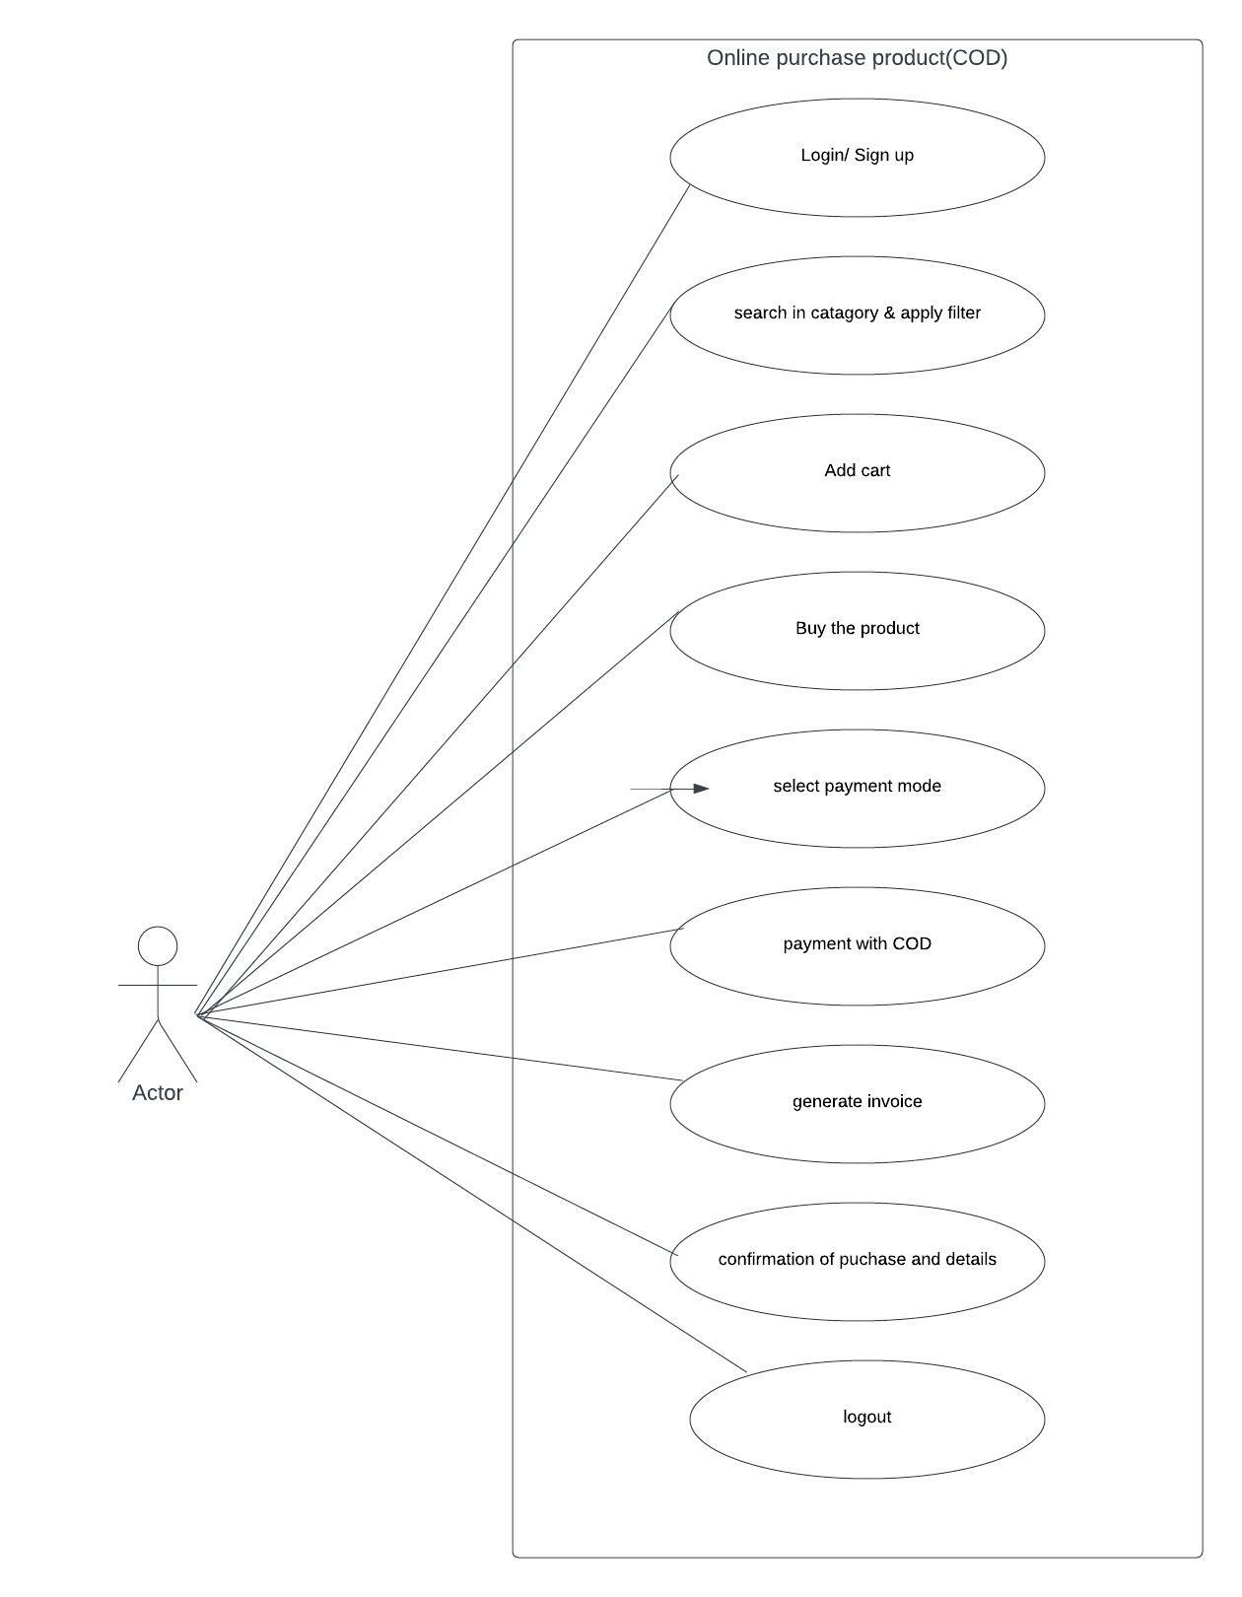

* Draw a use case for an Online shopping product using a payment gateway

